Marine Mammal Lab
Overview

Time: 1 hour
Group Size: Up to 45 students (10-15 students per group)
Grade Levels: 2nd – 3rd grade
Location: Sahm Marine Education Center

PROGRAM DESCRIPTION

In this program, the book The Snail and the Whale by Julia Donaldson and Axel Scheffler will be used to explore fact and fiction about whales. Students use microscopes to look at plankton and krill as they explore the diets of marine mammals, sort mammal and non-mammal artifacts, listen to sounds of whales, and look at fascinating whale “hitchhikers.”

INTRODUCTION

5 minutes only!
Keep it short! This program is hard to finish on time so do not use it up with introduction. Bring the students in and sit them on the floor in one large group. Show the book and ask if they have read it. If they have not, you will have to go over the main ideas quickly read a few parts if needed, but not all of it. Tell them you are going to divide them into X groups and go through four stations and to stay with the instructor. Divide into instructor groups and get started. Teachers often assign chaperones to a number of children and they do not always understand we need different sized groups. Work with them to divide the groups without breaking up too many of the teacher assigned groups.

FOUR STATIONS

1. What is a Mammal:
Students will learn the characteristics of a mammal. They will have the opportunity to observe, identify and then sort a variety of animal artifacts, replicas, and images into mammal and non-mammal categories. The mammals will then be sorted further into land (terrestrial) and marine mammal categories.

2. Feeding Strategies:
Students will learn about the feeding strategies of baleen whales vs toothed whales and will use microscopes to examine plankton and discuss its role in the food chain of a baleen whale. Students will learn about how different whales (baleen and toothed) may have very different diets based on their characteristics. Microscopes encouraged for programs with older students (3rd grade and up).

3. Exploration at the Discovery Pool:
Students will look at locomotion (moving) adaptations using snails and other animals in the discovery pool. After discussing whether or not the snail in the story would actually be able to attach to a whale, students will learn about barnacles and lice that do ride on whales and examine different types of invertebrates in our Discovery Pool. They will discuss attachment strategies and adaptations needed for living on a whale. Students will have the opportunity to observe and gently touch animals from the OEC Discovery Pool.

4. Whales and Sound Waves:
Students will learn about communication and echolocation abilities of whales after examining a dolphin skull, using tuning forks and a hydrophone to experiment with sound waves and sound production, and viewing video/sound clips of whales.

SCHEDULE/LOGISTICS

Perfect Timing Example: 12 minutes per station
9:30 – 9:38 Bring them in, set them down, do introduction
9:38 – 9:50 Station One
9:50 – 10:02 Station Two
10:02 – 10:14 Station Three
10:14 – 10:26 Station Four
10:26 – 10:30 Line up and out the door

- Program Set Up:
There are a lot of items to set up so you must be on time and work efficiently.

- Bring Them In:
Be on time! When possible, go out front to bring students in a few minutes before start time. At least two or three instructors should go out to greet them. Make sure they have checked in at the front desk and get a reliable count of students. Have one instructor follow and close the gate.

- Give Introduction and Break into Groups

- Station rotation (12 minutes each): 1) What is a Mammal; 2) Plankton and Baleen Whales; 3) Exploration at the Discovery Pool; and 4) Whales and Sound Waves

- Start on time but make sure to stop 3-4 minutes early to start moving the groups out so the next group can get in on time. It takes younger students a long time to get organized and out of the room.

- This program has a lot in it and can be a challenge to finish on time, but it can and needs to be kept on time. Work efficiently and remember some stations have two parts.

- We do not do many of these programs so if you get scheduled for one and you have not seen it, talk to your supervisor right away and we will set up a training before the program.

- DO NOT do the bubble tank with any group! This takes too much time and if one group does it, they all want to do it. NO time for it.

- We request only one chaperone for every six students, but they often bring a lot more. You can include chaperone rules in the introduction. If the total group size gets too large, take the chaperones aside and talk to them about assisting with student behavior and keeping everyone on task.

- Conclusion/Ending Program:
Finish on time, line them up at the door. Make sure they know their program is over and ask the teacher what is next for them (lunch, baby beach, gift shop, and/or bus). Direct them to where they need to go. Make sure they understand they are to leave the campus.

ROOM DIAGRAMS

Husbandry
Quarantine Room
Bone
Lab
Back Courtyard
Sahm Marine Education Center

Kitchen
3
Sink

Artifacts
Sounds
4

Storage

Habitat Tanks
Feeding Strategies

Horn Shark Touch Tank
Baby Lab Materials

2

Jewel
Tanks
Touch Tank
Habitat Tanks

Octo Tank
Tank
Tank
Tank

1

Entrance

Stations (in order):
- Exploration at the Discovery Pool
  - Barnacles and whale lice may be placed on the one acrylic lid that stays on the tank.
- Feeding Strategies
  - One or Two blue lab tables- one for feeding strategies activity (required for all programs) and one for microscopes (3rd grade and up)
- What Is a Mammal
  - Push together two blue lab tables and place artifacts around the perimeter
- Whales and Sound Waves
  - One blue lab table for hydrophone, water tub, tuning forks and dolphin skull display

STANDARDS

NGSS EXCERPTS DIRECTLY RELATED TO:
Exploration at the Discovery Pool Station
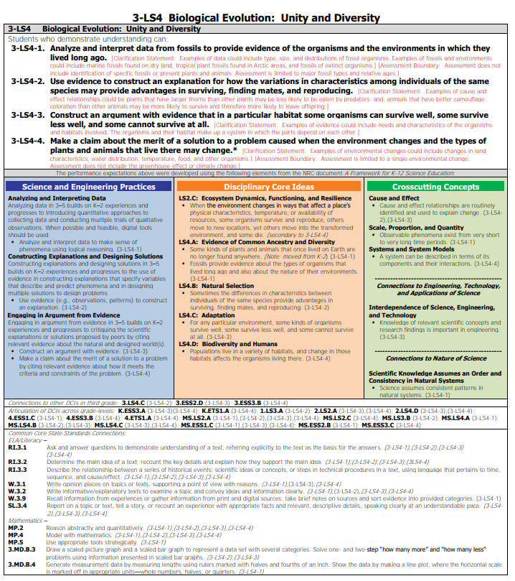
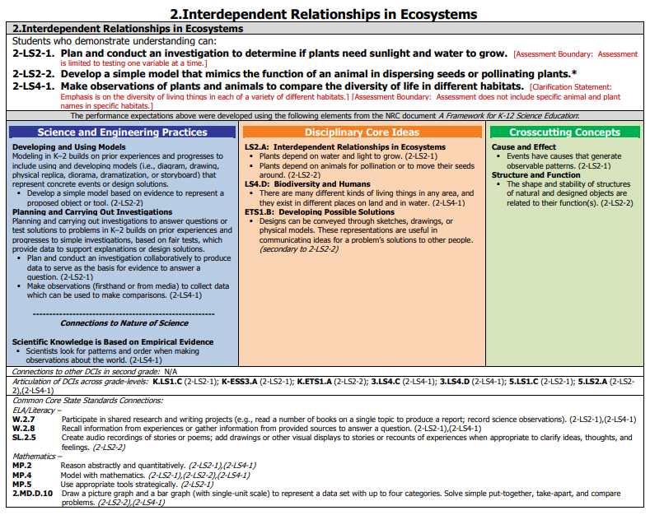

Plankton and Baleen Whales Station
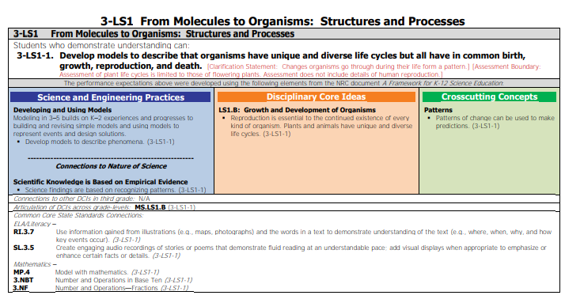

What is a Mammal? Station
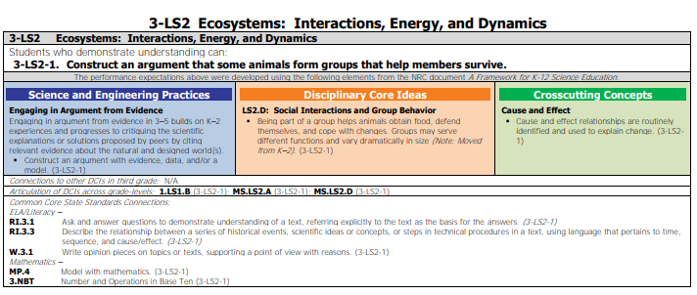

Whales and Sound Waves Station
